Lab # Kernel Debugging — Assessment Worksheet

**Course Name and Number: IAM302**

**Student Name: Tran Thanh Tuan**

**Student Id: SE161095**

**Instructor Name: Vu Duc Ly**

## **Setting Up Kernel Debugging**

***Taking a Snapshot***

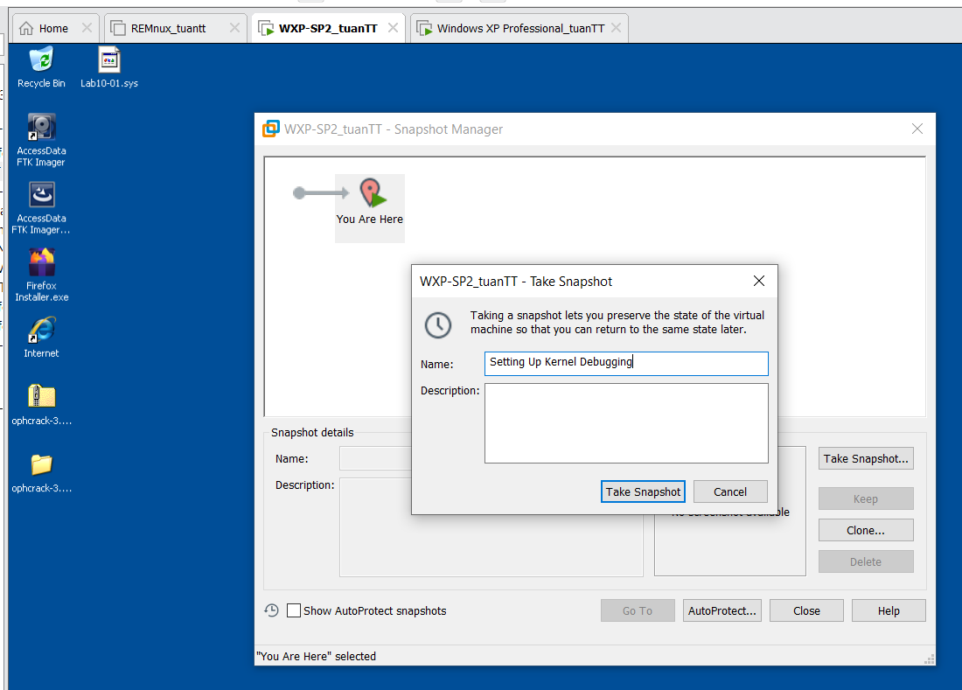

***Editing C:/boot.ini***

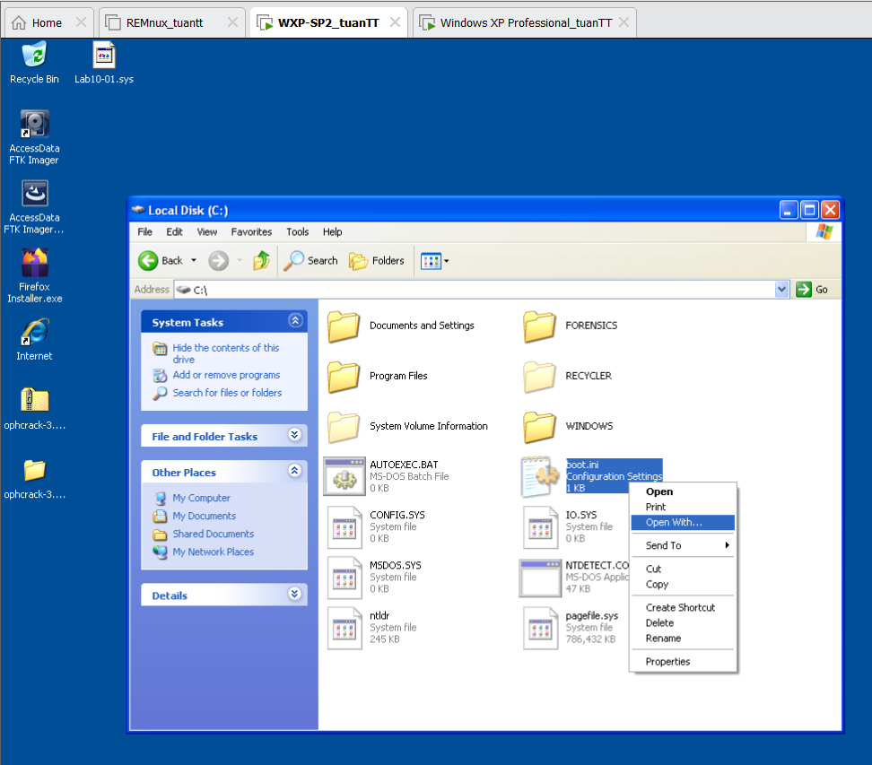

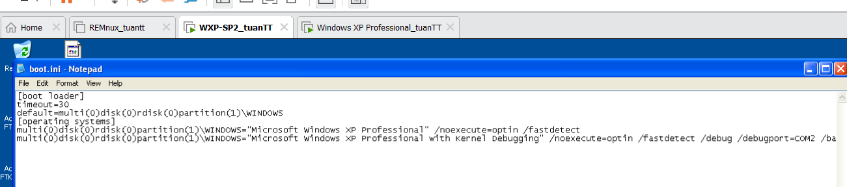

***Connecting the VM to the host***

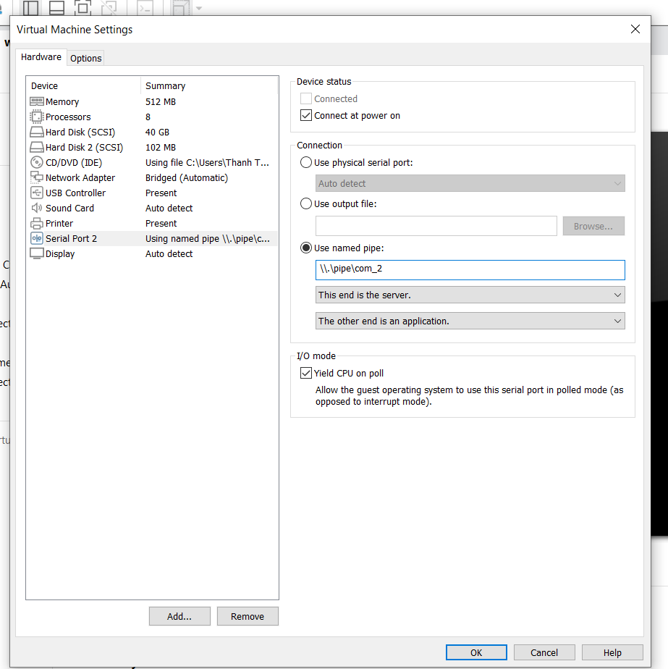

***Using Windbg***

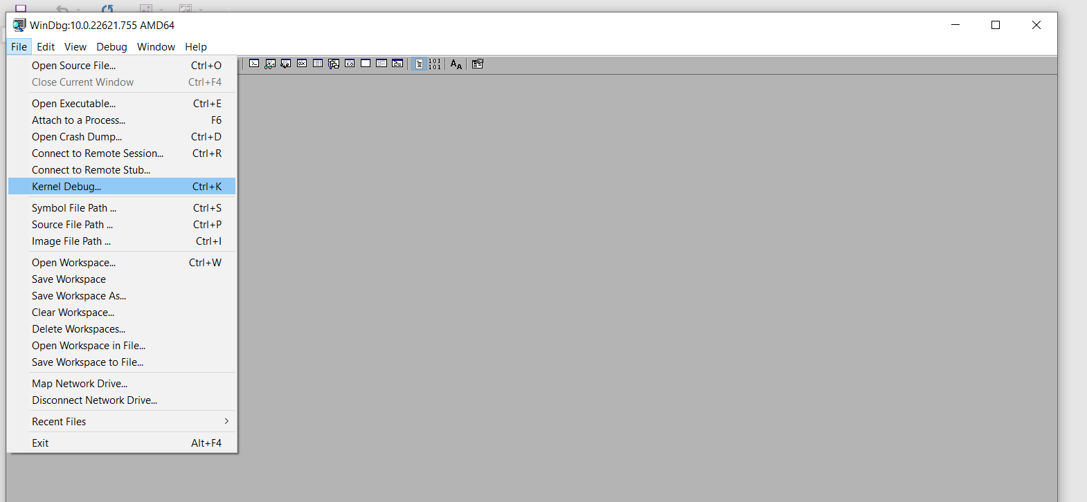

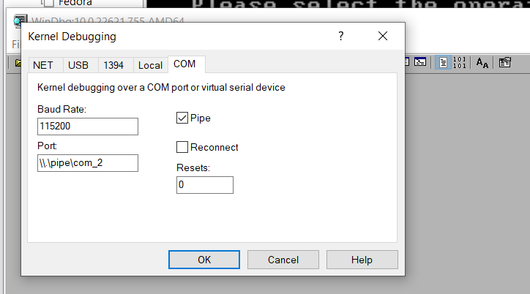

***Rebooting the VM***

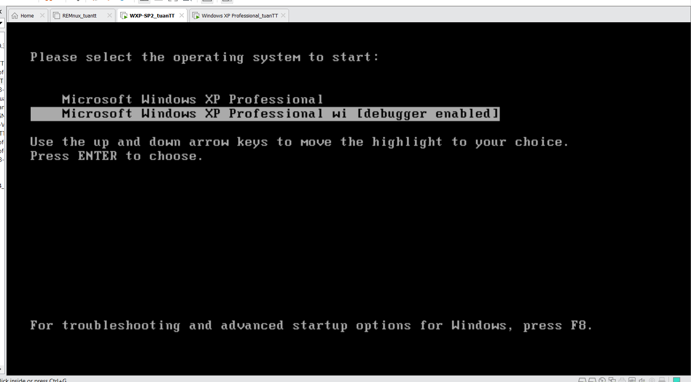

***Result***

